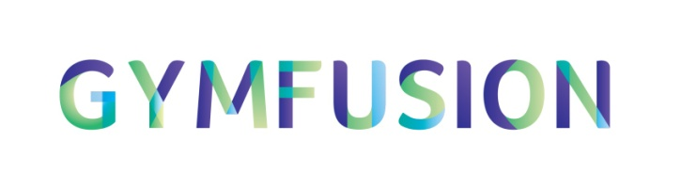
GymFusion Hemel Hempstead
Sunday 8th February 2015
Performance 1: 1:00pm – 3:00pm
Performance 2: 4:30pm – 6:30pm
Sport Space Hemel Hempstead, HP1 1JS
Spectator Ticket Order Form

Please complete the form below in BLOCK CAPITALS.
Cheques should be made payable to “British Gymnastics”.
Please return order forms and payment to: Natasha Lovett, GymFusion Newcastle Tickets, British Gymnastics, Ford Hall, LNSC, Newport, Shropshire, TF10 9NB
Any queries please contact: Lizzy Campbell on 07825 056 156 or elizabeth.campbell@british-gymnastics.org
Name:
Club:
Telephone Number:
Postal Address:
Email Address:
Ticket Type | Quantity | Performance | Sub-Total
Adult Advance: £10
Child Advance £7.00:
(Under 16’s)
Adult Advance Both Shows £15.00 |  | N/A
 | Delivery (60p) | Collection (free) | Sub-Total
Method of Delivery:
Total Cost:

Does anyone in your party have any accessibility issues that we should be aware of?
Please note: Children under 5 go free, providing that they do not require their own seat.

- Ticket orders for delivery must be received no later than 30th January 2015.
- Collection tickets will be available at Sport Space on 8th February 2015.
- Orders will not be processed unless payment is included.

